Most of the things that we see around us are circular. Sun, moon on full moon day bangle mery-go around, which you loved so much when you where a child; all happened to circles. Ever wondered how a circle can be represented mathematically; well no!!, then we will tell you in this chapter. Also we will take about tangent normulas, chords which we all have hear about. So let us prove deep in to circles.
Definition: locus of a set of points equidistant from a fixed point Equation ofcircle -
(x - h)²+ (y - k)² = r ²
x²h ₂ - 2hx + y² - 2ky + k²- r² = 0
x²+ y² + 2gx + 2fy + C = 0
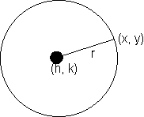
Center
Genreal second degree equation-
ax²+ by² + 2hxy + 2yx +2fy +C = 0
this equation refresent circle when,
a = b,h = 0 , g² + f² C
Equation of circle in different forms -
(1) Centre(h₁K) radius a :-
(x - h)² + (y - k)² = a²
standard form (when center is origin):-
x² + y² = a²
(2).center (h,k)and pass through origin-
x² + y² - 2hx - 2ky = 0
Why :-
here
(x - h)² + (y - k)² = r² = h² + k²
x²+ y² - 2hx - 22ky = 0
Center(h,k) and touches the axis of x-y
x²+y²- 2hx - 2ky + h²= 0
(x - h)² + (y - k)² = k²
or, x²+ y² - 2hx - l2ky + h² = 0
(4)Center(h,k) and touches the axis of y-
x² + y²-2hx -2ky + k² = 0
Why :-
From fig it is clear that radius will be h .
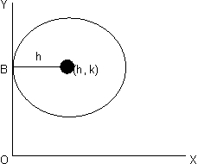
(x - h)² + (y - k)² = h²
or, x²+ y²- 2hx - 2ky +k² = 0
Circle which touches both the axis:-
Center will be(h, h)and radius will be h. But since center would be in any of the four quadrants its coordinates can be taken as radius h.
Illustration -1-. Find the equation of circle passing through (-2, 3) and touching both the axes.
Solution- As the circle toucher both theaxed and lies in 2ndquadrant, lits centre is Where r is the radius , Distance of center from (- 2, 3) = radius .
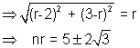
the circle are :- (x + r)² + (y - r)² = r²
X² + y²+ 2agx + 2fy +c = 0 ----equation of circle.
x intercept
Why :-
let it cut the axis x ie y = 0
in points (x₂,0) and (x₂, 0)
x₁, x₂ are the roots of x² + 2yx + c = 0
x₁, x₂ = - 2y , x₁ . x₂ = c
Intercelt = x₂ - x₁
= [(x₂ + x₁)²- 4x ₁x₂] ^{1/2} =
similarily .y intercept =
(6) Circle whose diameter is the line joining two point A (s₁, y₁ ) and B (x₂, y₂)-
Diametric form:-
(xx- x₁)(x - x₂) + (y - y₁(y - y₂) = 0
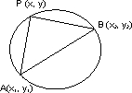
Why :-
Angle in a semicircle is a right angle
m₁m₂ = - 1
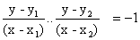
or (x - x₁)(x - x₂) + (y - y₁)(y - y₂) = 0
(7) Parametric form-
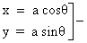general point of a circle if centre is (0,0) isparameter (radius)
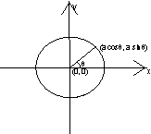
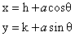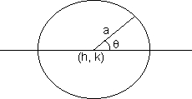
Illustration -2- Find the equation a circle which touches the .y axis at (0, 4) and cuts an intercept of length .6 units on x axis .
Solution- The equation of circle toching x = 0 at (0,4) can be taken as (x - 0)² + (y - 4² ) + kx = 0
x² + y² + kx - 8y + 16 = 0
the circle cuts x -axis point (x₁, 0) .8 (x₂, 0 )given by, x² + kx + 16 = 0
Xintercept difference of root of this quadratic equation 6 = | x₂ - x₁|
36 = (x₂ + x₁)² - 4x₁ .x₂
36 = k²- 4 (16)
k = 10
Hence the required circle is ,
x² + y²10 x - 8y + 16 = 0
Some natations in a circle-
1) s = x² + y² + 2gx + 2fy + c
2) s₁= x x₁² + y₁² + 2yx₁ + 2fy₁ + c
3) T = xx₁ + yy₁ + g(x + x₁) + f (y + y₁) + c
Standrad form-
1)s = x² + y² - a ²
2)s =₁x₁² + y₁ ² - a²
3) T = xx₁ + yy₁ - a2
* If s₁> 0 point lies out side the circle
* If s₁< 0 point lies in side the circle
* If s₁ 0 point lies upon the circle
Why :-
Let equation of circle be X² + y² + 2yx + 2fy + c = 0
having centre C( -y, -f) and radius
Let P (x₁, y₁) be any point then :-
P lies outside the circle if :-
PC > r
=> x₁ ² + y₁² +2 yx ₁ + 2fy₁ + c > 0
P lies on the circle if :-
PC = r
=> x₁ ² + y₁² +2gx₁ +2fy ₁ + c = 0
P lies inside the circle if :-
PC < r
=> x₁² + y₁² +2gx₁ 2fy₁ + c < 0
Dumb question :-
How does PC > r leads to -
x₁²+ y₁² + 2gx₁ + 2fy₁ + c > 0
Ans-
and r =
Now PC > r
=> PC² > r²
=> (x₁ +y)²+(y₁ +f)² > y² + f ²- c
=> x₁² + y₁² 2gx, + 2fy₁ + c > 0
(1) A line L and a circle intersed in two point A and B .
=> d < r 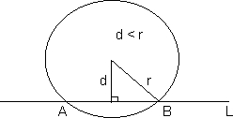
=> Perpendi cular distance of line L from the centre of circle is less than the radius, and the length of te chors AB is :-
(2) A line L and +a circle touch each other at a point P.
=> d = r
=> Perpendicular distance of L from the centre of circle = radius.
(3) A line L and a circle may not intersect at all
=> .d > r
=> Perpendicular distance of line from the centre of circle is greater than the radius .
(4) A line y = mx + c touches circle x² + y² = a²
If :- perpendicular distance of line from centre of the circle
= radius of the circle
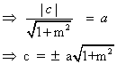
Illustration- For what value of m, will line y = mx does not intersect the circle x²+y² + 20 X +20y + 20 = 0
Solution- IF the line y = mx does not intersect the circle ; the perpendicular distance of the line from the centre of the circle must be greater than its radius .
Centre of circle (-10, -10) ; radius
distance of line mx - y = 0 from (-10, -10)
=> |m(-10)-(-10)|
=>(2m + 1) (m + 2) < 0
=> -2 < m < - 1/2
Intersection of line with circle-
Let the line be y = mx + d and circle is x²+ y² +2gx + 2fy + c
thes x. Coordinate of their point of intersection are given by, (1 + m²)x2+ (2g + 2fm +2dm) x + d²+ 2fd + = o
Why :-
When the two curves intersect, both the curves will be simultaneously satisfied.
So y = mx + d can be replaced in
x²y² + 2gx + 2fy + c =0
=> x² + (mx + d )² + 2gx + 2f (mx + d) + c =0
=> (1 + m)² + (2g + 2fm + 2dm) x + d² + 2fd + c = 0
if. (i) B² - 4AC = 0 then line touches the circle.
(ii) B² - 4AC = > 0 then the line intersect circle at 2 different point.
(iii) B² - 4AC = < 0 then no real intersecti takes place.
Illustration 4- Find the point on the circle x² + y²
= 4 whose distance from the line 4x + 3y = 12 is 4/5 .
Soluction- Let A,B be the point on x²/u> + y² = 4 luing ar a distance 4/5 from 4x + 3y = 12
=> AB will be parallel to 4x + 3y = 12
distance between the two line is 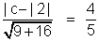
=> C = 16, 8
=> the equation of AB is :- 4x + 3y = 8 4x + 3y = 16
the point A,B can be formed by sliving for point of intersection of x² y² = 4 with AB.
AB(4x + 3y - 8 = 0)
=>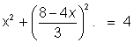
=> 25 x² - 64x + 28 = 0
=> x = 2, 14/25
y = 0, 48/25
AB (4x + 3y - 16 = 0)
=> 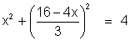=> 25 x² - 128 x + 220 = 0
=> D < 0 => no real roots
Hence these are two pointr on circle at distance 4/5 from liine
A(2,0) . & B (14/25, 48/25)
Alter native method -
let P be the point on the circle x² + y²= 4 distance . 4/5 from given line. the distsnce from line = 4/5
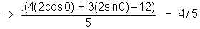
Solve for to get the point .
Equation of tangent in general form is :-
xx₁ + yy₁+ g(x + x₁) + f(y + y₁) + c = 0
equation of tangent on standard form :-
xx₁ + yy₁ a² = 0
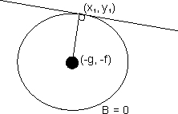
Why :-
Slope of tangent = -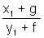
equation of tangent :-
y - y₁ - (x - x₁)
(y - y₁) (y₁ + f) = - (x₁ + y) (x - x₁)
on solving we get,
xx₁ + yy₁ + g (x + x₁) + f (y + y₁) + = 0
Equation of tangen T = 0 >
Dumb question- Why slope of tangent 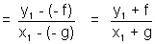?
Ans - The slope of line Joining the centre to point of contact is
Now tangent os perpendicular to this line -
slope of tangent is - 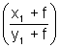
Note:- Golden rule to write equation of tangent is to replace. x² xx₁, y² yy
1
2x x + x₁, 2y = y + y₁ in equation of circle where (x₁, y₁) is of contact.
Equation of tangent.
Lngth of tangent:-
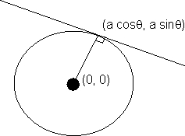
length
Why :-
let equation of circle be
x² + y² + 2gx + 2fy + c = 0
then center is c(-g, -f) and radius = f
length of tangent = PA
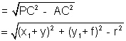
on solving we get ,
length of tangent
length
Condition of or line y = mx + c to be a ltangent to x²+ y² = a² -
Condition:-
c² = a² (1 + m²)
Equation of tangent:-
y = mx
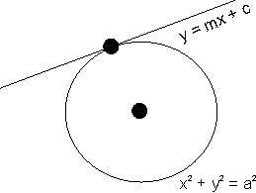
Why -?
putting y = mx + c in x² + y² = a²
x² + (mx + c)² = a²
(1 + m²) x² + 2mxc + c² - a² = 0
4m ² - c² -4 (c² - a² ) (1 + m²) = 0
c² = a²(1 + m²)
Similarily when circle equation is -
(x - h)² + (y - k)² = a²
equation of tangent with slope m
=> (y - k) = m (x - h)
Dumb question :- Why D is taken zero ?
Ans- Line is touching circle.
It means on ksolving line and circle -
We will get only are solution -
It means quadratic of x will lhave repeated roots if means D = 0
Illustration- Find the equation of two tangents drawn to the circle x² + y² - 2x + 4y = 0 from point (0, 1)
Solution- let m be the slope of the tangent .
For true lengths here will be two values of m which are requited.
As the regent pases through (0, 1) its equation will be .
(y - 1) = m(x - 0)
mx - y + 1 = 0
Now the centre of circle (x² + y² - 2x + 4y = 0) is (1,-2) and radius r =
So using the condition of tangencu distance of centre (1, - 2) from line = radius (r)
=> m = 2, -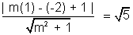1/2
equation of tangents are :-
2x - y = 1 = 0 and x = 2y - 2 = 0
Illustration:- Find the equation mcircle passing through (-4, 3)an touching the line x + y = 2 and x - y = 2.
Solution .- let (h, k) be the centre of the circle the ditance of the centre from th given line and the given point must be equation to radius :-
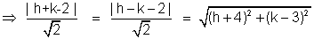
<>br /> Consider 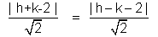
=> h + k - 2 = (h - k - 2)
Case(I)- h + k - 2 = h - k -2 => k = 0
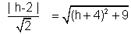
=> (h - 2)² = 2(h + 4)² + 18
=> h² + 20h + 46 = 0
=> k = 10
radius = 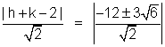
Circle is :
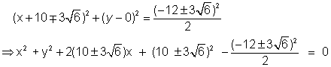
Case(II) - h + k - 2 = - (h - k - 2)
=> k² = 72 + 2 (k - 3)²
=> k² = 12 k + 90 = 0
The equation has no real roots. Hence no circle is possible for h = 2 .
Hence only two circle are possible (k = 0)
Pair of tangents -
T ² = ss₁
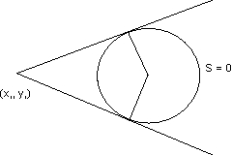
Equation of normal-
The normal to a curve at any P of a curve is the straight line which passes through P and is perpendicular to the tangent at P .
The equation of normal to the circle x² + y² + 2gx + 2fy + c = 0 at any point l(x₁,y₁) is :-
y(x₁ + g) - x (y₁ + f) +fx₁ + gy₁ = 0
Why :-
normal will be OP
slope OP = 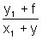
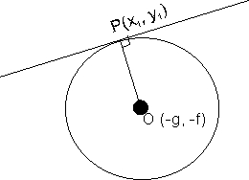
equation of normal -
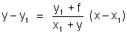
on sloving we get,
y(x₁ + y) - x(y₁ + f) + fx₁ - gy₁ = 0
With respect to circle S = 0
Equation of chord of contact:-
T = 0 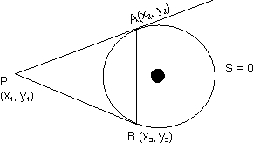
Why :-
Equation of circle S = 0
Whose, S = x² + y² - a²
Equation of AP => xx₂ + yy₂ - a² = 0
Equation of BP => xx₃ + yy₃ - a² = 0
Both passes through P .
x₁x₂+ y₁y₂ - a² = 0 ..............(1)
x₁x₃+ y₁y₃ - a² = 0 ..............(2)
Now consider
xx₁+ yy₁ - a² = 0 ..............(3)
from (1), (2) and (3) it is lvery that clear that A and B
lies on (3)
equation of AB is xx₁+ yy₁ - a² = 0
=> T = 0
Equation of chord lhaving mid point (x₁, y₁)
Only one such chord is possible
Equation of chord
T - s₁ = 0 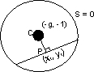
xx₁+ yy₁ +g(x + x₁) + f (y + y₁) + c
= x₁² + y₁² + 2gx₁ + 2fy₁ + c
Slop of CP = -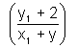
Equation of CP =>
(y - y₁) = -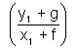(x - x₁)
on solving we get,
T = S₁
T - S₁ = 0
Illustration- Find the co-ordinates of the point from which tangen are drawn to the circle x² + y² - 6x - 4y + 3= 0 such that mid point of its chord of contact is (1, 1).
Ans- S = x² + y² - 6x - 4y + 3
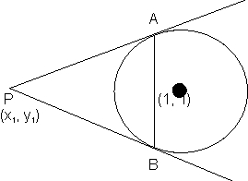
T_{AB} = xx₁ + yy₁ - 3(x + x₁) - 2(y₁ + y₁) + 3
(x₁ - 3) x + (y₁ - 2) y - 3x₁ - 2y₁ + 3= 0........(1)
Equation of AB T - S₁ = 0
on solving
2x + y = 3 ............(2)
Comparing (1) and (2)
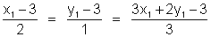
on solving, .
x₁ = - 1, y₁ = 0
In previous illastration why .
Why not x₁ - 3 =2
y x₁ - 3 =2 ?
Solution - On comparing two equation -
a₁ x + b₁y + c₁ = 0
a₂ x + b₂y + c₂ = 0
If both the above equation are of some line, then we get :-
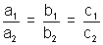
Two circle touching each other -
(a) External tiuch-
c₁ c₂ = r₁ r₂
Point P divides the line Joining c₁ & c₂ internally in th ratio
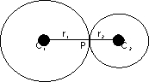
r₁; r₂
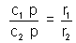
( b) Internal touch:-
c₁ c₂ = | r₁ - r₂|
point P divider the line Joining c₁ & c₂ externally in the ratio r₁ : r₂.
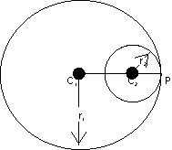
Conclition :-
|(r₁ - r₂)| < c₁ c₂ < r₁ - r₂
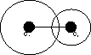
(a)One is completely inside other-
Conclition :-
c₁c₂ < r₁ - r₂
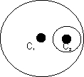
Illustration- Examine if the two circle x² + y² - 8y - 4 = 0 & x² + y² - 2x -4y = 0 touch each other find the point contact if they touch.
Solution- For x² + y² -2x - 4y = 0 centre c₁(1, 2)
& x² + y² -8x - 4 = 0 centre c₂(0, 4)
using
Now c₁c₂ =
=> r₂ - r₁=
For point of contact -
Let P(x, y) be the point of contact,
Pdivixles c₁c₂ externally in ratio of = 1 : 2
using section formula, we get,
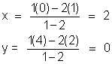
P(x, y)(2, 0) is the point of contact .
15 and touching the circle x² + y² = at point (6, 8).
solution- Case: It the required circle touches x² + y²
at (6, -8) centerally .
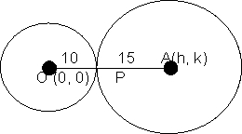
then P(6, -8) divider OA in the ratio 2 : 3 internally .
Let centre of the circle be (h, k). Now using section formula,
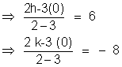
=> h = 15, & k = -20
=> (x - 15)² + (y + 20)² = 225 is the required circle .
Case-2 If the required circle touches x² + y² = 100 at (6, -8)internally, then P(6, - 8) divides oa in the ratio 2 : 3 exerternally .
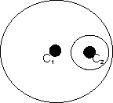
=> h = - 3 and k = 4
=> (x + 3d)² + (y - 4)² = 225 is the required circle .
(1) If two circle neither intersect nor touch eache other then they have 4 common tangents.
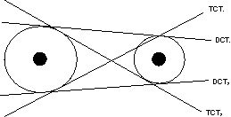
DCT means direct common tangent
TCT means Transverse common tangent .
(2) If two circle touch each other extenally then there are 3 common tangents .
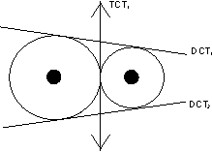
(3) If two circle intersect each other at 2 point then there are 2 common tangents.
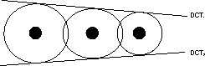
tangent is possible .
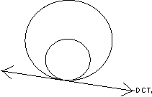
(5) If two circle are concentric then there is no common tangent between them .
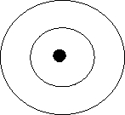
Director circle - The locus of meeting point of perpendicular two is also a circle concertric with the given circle is called director circle of the given circle .
Equation of given circle -
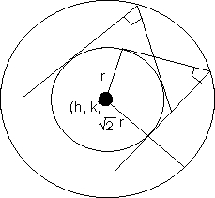
(x -h)² + (y -k)² = r²
Equation of director circle-
(x -h)² + (y -k)² = 2r²
Question- The line and meet at point (h, k) find the locus of point (h, k) for various values of .
Ans- Note that the line and are perpendicular to each othe and both are tangent to circle x² + y² = a² .
So, the locus of point of intersection of the two kof tangents ie, (h, k) is director circle with equation -
(1)Equatio of family of circle passing through point of intersection of a circle (s = 0) and a line (L =0) is given by -
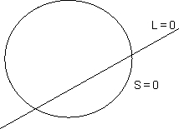
Illustration- Tangents PA and PB are drawn from the point P to circle x² + y² = a² . find the equation of circum circle ofPAB and the area of PAB.
sloution - AB is the chord of contact for point P.
Equation of AB is :-
hx + ky = a²
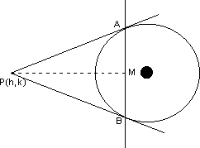
The circum circle of PAB passes through the intersection of circle. x² + y² - a² = 0 and the line hx + ky - a² = 0.
using S + KL = 0 (family of circle)
we can write equation of circle:-
(x² + y² - a² + k(hx + kg - a²) = 0 where k is paramete.
As this circle passes trough p(h, k);
=> h² + k² - a² + k(h² + k² - a²) = 0
=> k = - 1
The circle kis = 1/2 PM AB(PM AB)
PM = distance of p from AB
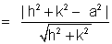
PA = length of tangent from P =
area =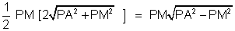
area 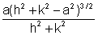
Note taht h² + k² - a² > 0
(h, k) lies outside the circle .
(2) Equation of family of circle passing through points of intersection of two given circle -
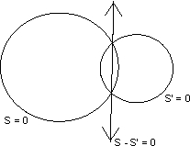
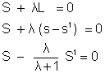
S + KS¹ = 0
(3) Equation of family of circle through .
two fixed given points .
S and L can be find out as fallows
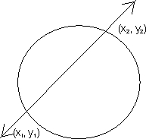
S = (x - x₁) (x - x₂) + (y - y₁) (y - y₂) = 0
(diametric form)
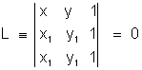
Illustration- Find the value of t so that the point (1, 1), (2, -1), (3, -2). and (12, t) are concyclic .
We will find the equatiion of the circle passing through A, B & C and then find t so that D lies on that circle .
Any circle passing through A, B can be taken as :-
(x - 1)(x - 2) + (y - 1)(y + 1) + K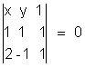
=> x² + y² - 3x + 1 + k (2x + y - 3) = 0
c(3, -2) lies on this circle .
=> 9 + 4 - 9 + 1 + k(6 - 2 - 3) = 0
=> k = - 5
=> circle through A; B & C is :-
x² + y² - 3x + 1 - 5 (2x + y - 3) = 0
x² + y² - 13x - 5y + 16 = 0
Point D (12, t) .will lie on this circle if :-
=> 144 + t² - 156 - 5t + 16 = 0
=> t² - 5t + 4 = 0
=> t = 1, 4
=> for t = 1, 4 the point are concyclic.
(4) Equation of family of circles through .
one point an a fixed given line-
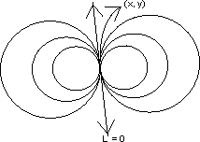
S = (x - x₁)² + (y - y₁)² = 0
Illustration- Find the equation of a circle touching the line x + 2y = 1 at the point (3, - 1) and passing through the point (2, 1).
the point (3, 1) can be talen as :-
(x - 3)² + (y + 1)² + k(x + 2y - 1) = 0 (using family of circle )
As the circle passes through (2, 1)
(2 - 3)² + (1 + 1)² + k(2 + 2) = 0
=> k = - 5/3
=> the required circle is :-
3 (x² + y² - 23x - 4y + 35 = 0
Orthognal cut of two circle-
If two circle are cutting each other orthogonally then the tangents at the point of intersection is perpendicular to each other :-
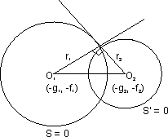
(O₁o₂)² = r₁² + r₂²
(g₁ - g₂)² + (f₁ - f₂)² = g₁² + f₁² - c₁ + g₂² + f₂² - c₁
2g₁g₂ + 2f₁f₂ = c₁ + c₂
Illustration - The center of circle S .line on the line 2x - 2y + 9 = 0 and S cuts at right anges the circle x² + y² = 4 . Show that S passes through two fixed point and fond heir coordinates
Contre lies on 2x - 2y + 9 = 0
=> - 2g + 2f + 9 = 0 ..........(1)
So cuts x² + y² - 4 = 0 orthogonally -
=> 2g (0) + 2f (0) = c - 4
=> c = 4 ...............(2)
Using (1) and (2) the equation of S be come :-
x² + y² + (2f + 9) x ++2fy + 4 = 0
=> (x² + y² + 9x + 4) + f(2x + 2y) = 0
We can compare this equation with the equation the family of circle through the point of interectin of a circle and a line (S + FL = 0, where f is a parameter).
Hence the circle S always pass through two fixed point A and B . Which are the point of intersection of x² + y² + 9x + 4 = 0 and 2x + 2y = 0
Solving these equation we get,
x² +xy² + 9x + 4 = 0
=> x = - 4, -1/2 => y = 4, 1/2
=>A (- 4, 4) & B (- 1/2, 1/2)
Radical axes- Locus of a point which moves such mthat mthe tangents drawn from tjhis point oto the two given circle will be of equal in lingth .
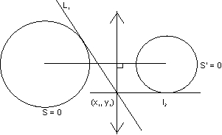
l₁ = l₂
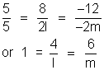
S₁ = S₁¹
equation of radical axes S₁ = S₁¹ = 0
Illustration- Find the equation of radical axes of the circle
S = x² + y² + 4x - 6y + 3 = 0
S¹ = 3x² + 3y² - 12x + 9y + 1 = 0
Ans- S₁ = S₁¹
=> x₁² + y₁² + 4x₁ - 6y₁ + 3 = x₁² + y₁² - 4x₁ + 3y₁ + 1/3
=> 24 x₁ - 27y₁ + 8 = 0
Important Results:-
(1)When circle are touching each other, the radical axes is the common tangent beween them.
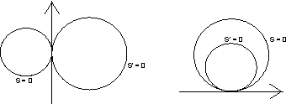
axes is common chord between them :-
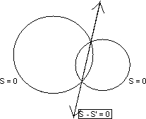
Radical centre- If there are thre circle (whose centre are not clooinear.) then there will be three radical axes. All these three radical axes are concurrent . And the point of concurrency is called radical centre.
* Radical axes are perpendical to kthe line Joining centre of the circles .
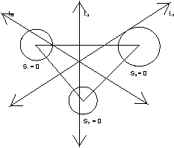
L₂₃S₂ -S₃ = 0
L₁₂ S₁ - S₂ = 0
adding above three -
L₁₃ = - (L₂₃ + L₁₂)
pair of lines.
Co axal System of circle-
A system of circle is said to be co axial when they have common radical axis ie, when radicaal axis of each pair of circles of system is same .
Illustration-
For what values of l and m the circle 5(x² + y²) + ly - m =0 belongs to the coaxal system determined by pthe circle .
x² + y² + 2x + 4y - 6 = 0 and 2² + y²) - x = 0 ?
Ans- If the radical axis for each pair of the three given circle is the same them the result is established.
Let the circle be .
S₁ = x² + y² + 2x + 4y - 6 = 0
S₂ = x² + y ² - 1/2 x = 0
S₃ = x² + y₂ + l/2y - m/5 = 0
the equation of radical axis of circle S₁ = 0, S₂ = 0 is S₁ - S₂ = 0
ie, x² + y² + 2x + 4y - 6 (x² + y² - 1/2x) = 0
or, 5/2x + 4y - 6 = 0
or, 5x + 8y - 12 = 0 ......................................................(1)
the equation of the radical axis of circle S₂ = 0, S₃ = 0 is S₂ - S₃ = 0
ie, x² + y² - 1/2x - (x² + y² + l/5y - m/5) = 0
or, 5x + 2ly - 2m = 0 .................................................(2)
(1) and (2) must be identical, so comparing them,
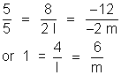
l = 4, m = 6
(Q | ) Find the equation of a circle which touches the line x + y = 5 at the point A(-2, 7) and cuts the circle x² + y² + 4x - 6y + 9 = 0 orthogonally .
(A |)
Since the circle is touching the line x + y - 5 = 0 at
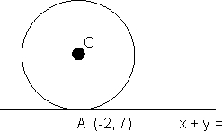
(-2, 7), its equation can be written as
(x + 2)² + (y - 7)² + K(x + y - 5) = 0 (whose k b vatiable
=> x² + y² + x (K + 4) + y(K -14) + 53 - 5 K = 0
It is orthogonal to the circle
x² + y² + 4x - 6y + 9 = 0
=> 2g₁ g₂ + 2f₁ f₂ = c₁ + c₂
=> 2(K + 4) - 3(K - 14) = 53 - 5 K + 9
4K = 12
K = 3
eqn of circle,
x² + y² + 7x - 11y + 38 = 0
DUNB QUESTION
(Q) Why in this question we used family of circles and not did it directly by taking an an arbitrary circle and applying the given information ?
(A) Whenever it is given that kthe the circle is fouduing a line L and the point of contact P is also given, then always as e the following pointly.
(x - x₁)² + (y -y₁)² + K L = 0 K is variable .
It makes the solution very easy as only one variable is left and we have used 2 conditions namely
(a) Line L is tangent to circle.
(b) Point of coutact lis P .
So only are mose in formation is needed to define the circle .
To define a circle we any three paramets
(Q2) Find the equation of circle passing through (- 2₁ 3) and touching both the axes.
(A2)
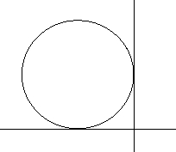
As the circle touches both the axes and lies in second quadeant, its contre is ;
C(- r₁ r) where r is the radius.
Distance of contre from (- 2, 3) = eadius.
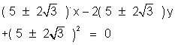
The circles we (x + r)² + (y - r)² = r²
(Q3) If ; i =1,2,3,4 are four distinct points on a circle, show that m₁ m₂ m₃ m₄ = 1
Let the eqn of circle be
x² + y² + 2gx + 2fy + c = 0
Now since is on the circle,
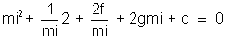
=> mi⁴ + 2g mi³ + cmi² + 2f mi + 1 = 0
The roots of this on are (m₁,m₂, m₃, m₄)
Product of the roots m₁,m₂, m₃, m₄ = = 1
Hence prooved .
Dumb question
(Q) Why are the roots of the above equation m₁,m₂, m₃,
m₄and how is m₁,m₂, m₃, m₄=18
(A) Since 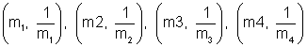
individually satiefy the equation of circle, hence they all must be the solution of m : . And hence it is equation of degree 4. For a fore degree eqn ax⁴ + bx³ + cx² + dx + e = 0 .
product of roots = e/a .
m₁,m₂, m₃, m₄ = 1.
(Q4) For what value of m, will the line y = mx does not intersect the circle
x² + y² + 20x + 20y + 20 = 0
(A4) If the line y = m, does not ointersect the circle, the perpendicular distance of the line from the contre must be greater than its radius.
Contre of the circle (- 10, - 10); radius 6r = 61.
distance of the line mx - y = 0 from (- 10, - 10) .
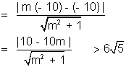
= (2m + 1)(m + 2) < 0
=> - 2 < m < - 1/2
(Q5) Secants are drawn from origin to the circle (x - h)² + (y - k)² = r². Find the locus of the mid - point of the portion of secants intercept inside the circle.
(A5)
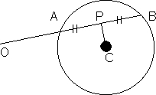
Let C(h₁ k) be the centre of the given circle . and P(x₁, y₁) be the mid point of the postion AB of the secant O AB.
=>
Slope COP) slope(CP) = - 1
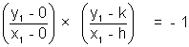
=> x₁² + y₁² - hx₁ - ky₁ = 0
the locus of the poine P : x² + y² - hx - ky = 0
A circle has radius equal to 3 units and its centre lies the line y = x - 1 . Find the equation of the circle if it passes through (7, 3) .
Ans - Let the centre of the circle be
It lies of the line y = x - 1
=> . Hence the centre is
=> The equation of the circle is
It passes through (7, 3)
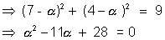
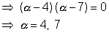
Hence the required equation are,
x² + y² - 8x - 6y + 16 = 0
and x² + y² - 14x - 12y + 76 = 0
Que - Prove that the circle x² + y² - 6x - 4y + 9 = 0 bisects the circumference of lthe circle.x² + y²- 8x - 6y + 23 = 0
Ans The given circles are
S₁x² + y² - 6x - 4y + 9 = 0 ........................................(1)
and S₂x² + y² - 8x - 6x + 23 = 0 .................................(2)
Equation of the common chord of circle (1) and (2) which is also the radical axis of the circle S₁ and ₂ is,
S₁ - S₂ = 0 or 2x + 2y - 14 = 0
or x + y - 7 = 0 .......(3)
Centre if the circle S₂ is (4, 3). clearly, line (3) passes through h point (4, 3) and hence line (3) is equation of diameter of circle (2)
Hance circle (1) bisects the circumfrance of circle(2)
extesnally. Find the angle beween the direct common tangents it given that r₁ > r₂.
Ans - let us draw the diagram.
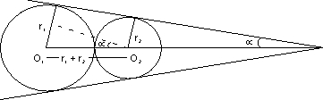
Cleatly
Now,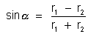
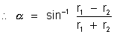
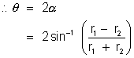
Q. Find th number of common tangents that can be drawn to circle x² + y² - 4x - 6y - 3 = 0
and x² + y² + 2x + 2y + 1 = 0 ?
Ans. The circle x² + y² - 4x - 6y - 3 = 0 has
Centre C₁ (2, 3) and radius r₁ = 4.
And the circle x² + y² + 2x + 2y + 1 = 0 has
Centre C₂ (-1, -1) and radius r₂ = 1
Now C₁C₂ =
= 5
Also r₁ + r₂ = 4 + 1 = 5 .
So, the two circle touch each other externally and thus 3 common tangents are possible.
Q. If two circle cut the third circle orthogonally, prove that their common chord will pass through centre of third circle.
Ans. Let us take equation of two circle as .
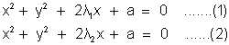
Let third circle be x² + y² + 2fy + c = 0 .....................................(3)
The circle (1) and (3) cut orthergonally .
So, = a + c. ...................................(4)
= a + c. .......................................(5)
from (4) and (5)
= 0
, as then circles would be same
So, g = 0
centre of third is (0, -f)
The common chord of (1) and (2) has equation S₁ - S₂
i.e x² + y² + 2₁x + a - (x² + y² + 2₂x + a) = 0
=> 2(₁ - ₂)x = 0
or x = 0
So centre (0, - f) satisfies equation x = 0.
Dumb Question. Why the equation of circle were taken to be x² + y² + 2i x + a = 0 ? Where did the 'y' term went ?
Ans- Such equation of the circle can be taken if we chose the axis suitably .
The axis can be chosen as the nline joining the centre of two circles as x - axis and the point midway between the centre as origin.
And then we can obtain the equation as used in the question
(Q 1) Let AB be a chord of the circle x² + y² = r² substens aright angle at the centre . Show that the locu of the coutroid of the triangle PAB as P mo ves on the circle is a circle.
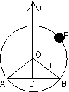
ODB is isosceles with OD = OB = x(say)
We may assume AB is parallel to and below x - axis .
x² + x² = r²=> x = r/
B is 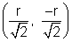and t is 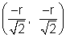
Let P be and centroid of PAB be G
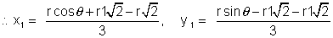
=> 3 x₁ =
Eliminating , we get
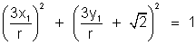
or x₁₂ + 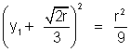 Locus of (x₁, y₁) is circle
(Q Dumb question )
Why was x² = r ²/2 implied
x = r 1 and correspondingly
A 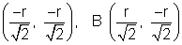.
(A) We have assumed OD as '+' ve y axis and OB '+' ve axis .
x - co-ordinate of B is positive
x = and its y co-ordinate (iv)quadrent is below y - axis axis
B
For A, x - co-ordinate on left of 0.
x = , and its y - co-cordinate is '-' ve (i.e. (iii) quadrant)
A 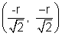.
(Q 2) The centre of circle S on use line 2x - 2y + 9 = 0 and cuts at right angles the circle x² + y² = 4 Show that S passes through two fixed point and find their co-ordinates.
(A 2) Let the circle S be : x² + y² + 2gx + 2fy + c =
centre lies on 2x - 2y + 9 = 0.
=> -2g + 2f + 9 = 0 .....................................(1)
S cuts x² + y² - 4 = 0 orthogonelly .
2g (0) + 2f (0) = c - 4 .
c = 4 - ........................................................(ii)
Using (i) and (ii) the equation of S becomes:
x² + y² + (2f + a) x + 2fy + 4 = 0
(x² +y² + 9x +4) + & (2x + 2y) =0
=> The circle S always passes through 2 fixed point A and B which are point of intersection of x² + y² + ax + 4 = 0 and 2x + 2y = 0
(as the above eqn can be compared to family circle S + KL = 0, where K is parameter).
Solving these eqn we get
x² + x² + 9x + 4 = 0
x = - 4, -1/2
y = 4 1/2 A (-4, 4), B (-1/2, 1/2)
Q3: The circle of X²+Y²-4X-4Y+4=0 is inscribed in atraingle has two sides long
the co-ordinates axes . the locus ofthe circumcenter of the traingle is x + y - xy + k
find the value of k.
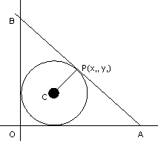
The given circle is (x-2)²+(y-2)²=4
=>centre=(2,2) and radius=2.
Let oab be the traingle in which the circle is inscribed. as OAB is right angled, the circumcentre is mid point of AB. Let p=(x₁,y₁) be the circumcentre.
A=(2x,0) & B(0,2y₁) THe eqn of AB is:,
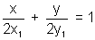
As AOB touches the circle, distance of AB=radius.
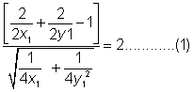
as the center (2,2) lies on the origin side of the line
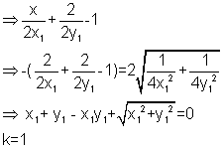
dumb question
(q) why is 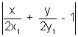taken -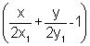 lies on the origin side of the line
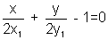
the expression has the same sign as the constant term (-1) in the eqn-
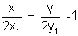is negative
Q4: Two circles each of radius 5 units touch each other at (1,2).if the equation of their common tangent is 4x+3y=10, find the equation of the circles.
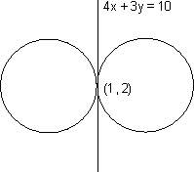
Equation of common tangent is 4x+3y=10. the 2 circles touch each other at (1,2)
. EQuation of family of circles touching a given line 4x+3y=10 at a given point (1,2) is
. (x-1)²+(y-2)²+k(4x+3y-10)=0,
x2+y²+(4k-2)x+(3k-4)y+5-10k=0
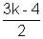and radius ²= g²+f²-c=(2k-1)²+()²-(5-10)
as the radius of the reqd. circle is 5
(2k-1)²+-(5-10k)=5²
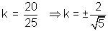
Put the values of k in 1 to get the Equation of reqd. circles
The reqd circles are
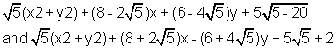
P is a variabe point on the line y=4.Tangent are drawn t the circle x²+y²=4 from p to touch it at A and B. the parallelogram. PAQB is completed. Prove that the locus of the point (y+4)(x²+y²)=2y²
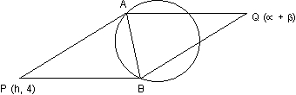
p lies on (y=4), then AB is chord of contact with respect to circle x²+y²=4 whose equation is
. hx + 4y = 4.........(1)
solving with circle we get
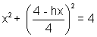
or x²(16+h²)-8hx-48=0
above gives abscissas of the point A And b,
x₁+x₂=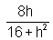
Also the points A and B lie on(1)
h(x₁+x₂)+ 4(y₁+y₂)=y+4
4(y₁+y₂)=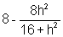
y₁+y₂=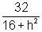
Now if the point q be , then the figure PAQ being a paralelogram its diagnal bisect
x₁x₂=h+=......(2)
y₁+y₂=4+=
Now we have to eliminate the variable between(2) and (3) to find the locus of Q i.e,
dividing 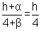4=h
or h=put in (3) and we get
(4+)(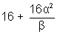)=32
locus is (y+4(x²+y²)=2y²

Q11. find all common tangents to s1=x2+y2-2x-6y+9=0
S2=x2+y2+6x-2y-1
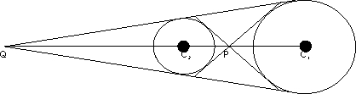
The centres and radii of the circles are c₁(1,3) and r₁=
c₂(-3,1) and r₂=
Transverse common tangents are tangents drawn from the point p which divides c1c2 internally
in the ratio of radii 1:3.
Direct common tanent are tangents drawn from the point q which divides c1c2 externally in th ratio 1:3
co-ordinate of p are:
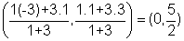
co-ordinate of q are:
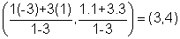
Transverse tangents are the tangents through any line through (0,5/2) is
(y-5/2)=mx or mx-y+5/2=0
apply the usual condition of tangency to any of the circle,
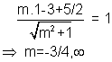
=> eqn of transverse tangents
3x+4y-10=0,x=0
direct tangents are tangents drawn from the p and q(3,4). let the eqn be (y-4)=m(x-3)
proceeding in same way,
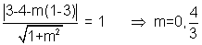
hence eqns of direct common tangents are
y=4,4x-3y=0
(Dumb question)
How does P and Q divide c1c2 externally and internally in the ratio r1:r2 and why in first case m is (for transverse tangents)
why?
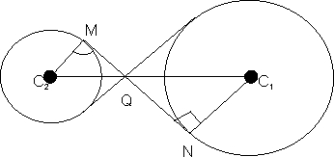
In C₂MQ and C₁NQ
C₂mq=c₁NQ=90
MQC₂=NQC₁(vertically opposite)
Hence,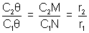
Now,(m),
Eqn was 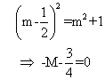
But since there are 2 values of m as there have to be 2 transverse tangents(isolated is not possible)
hence eqn is (o)m²-m-3/4=0
Now product of roots
if one is real and finite other root is infinite
Find the interval of values of a for which t line y+x=0 bisects 2 chord drawn from point 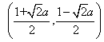to the circle
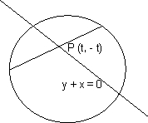
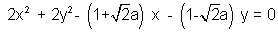
let m,n=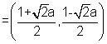
Equation of the circle reduces
x²+y²-mx-ny=0
let p(t,-t) be a point on the line y+x=0
Equatin of the chord passing through (t,-t) as mid -point 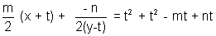
since chord (1) also passes through (m,n) it shows satisfy the equation of chord i.e
on substituting the values of m& n, we get
Now if there exists 2 chords passing through (m,n) and are bisected by the line y+x=0 then the equation of(2) should have real and distinct roots. D>0 => 18a²-16(1+2a²)/2>0
a²-4>0=>(a+2)(a-2)>0
hence values of a are
Q.3: the circle x2+y2 =1 cuts the x-axis at p and Q. another circle with center at Q and veriable redius intercept the first circle at R above x-axis and the line segment PQ at s. find the maximum of the triangle QSR.
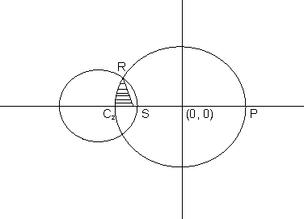
Equation of circle I is x² + y² = 1. it acts x-axis at point p(1,0) and Q (-1,0) Let the radius of the variable circle be r. center of the variable circle is Q(-1,0). Let the radius of the variable circle is (x+1)²+y²=r².........(2)
solving circle (1) and variable circle we get coordinate of r as 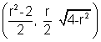
Area of the 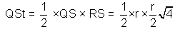
to maximise the area of the traingle to maximise the square,
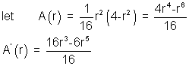
For A(r) to be maximum or minimum A'r=0
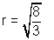
see yourself A''<0.
Area is maximum for
Maximum area of QRS = 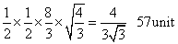
(Q.4) y = mx is a chord of the corcle of radius and whose diameter is along the axis of x. find the equation of the circle whose diameter is the chord and hence find the locus of center for all value of m.
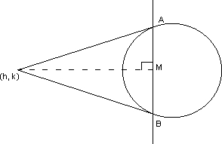
Ans. The circle whose chordf is y = mx and center lies on x-axis will touch y-axis at origin. The equation of such circle is given by (x-a)² +y²=a²=>x²+y²-2ax=0.......(1)
furher family of circles passing through the intersection of circle (1) and the line y=mx is
x²+y²-x(2a+km)+ky=0
center of the circle is =(a + km/2.- k/2)
we require that the member of this family whose diameter is y=mx.
-k/2=am+km²/2
=> k=-2ma/(1+m²) => center of the requird circle lies on y=mx
Put the value of k in (1) to get the eqn of circle
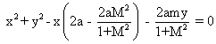
(1+m²(x²+y²)-2a(x+my)=0........(2)
let the coordinate of the point whose locus is reqd. be (x1,y1)
=>(x1,y1) is the centre of the circle (2)
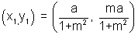
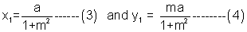
on squaring and adding (3) and (4) we get:
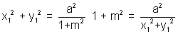
substituting the value of (1+m²in (3) to get:)
x1²+y1²=ax1
required locus: x,sup>2+y²=ax Tangents PA and PB are drawn from point (h,k) to the circle x²+y²=a²
find the equation of circumcircle of PAB and the area of PAB
AB is the chord of contact for point p. Equation of ab is HX+ky=a²
the circumcircle of PAB passes through the intersection
of circle. x²+y²-a²=0 and the line hx+ky-a=0
using s+kl=0, we can write the wequation of circle as: (x²+k²-a²)+k(h²+k²-a²)=0
=.k=-1
The circle is x²+y²-hx-ky=0
Area of PAB= 1/2 PM X AB (PM is to AB)
PM= distance of p from AB
=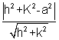
PA= length of tangent from p
AREA=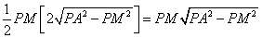
AREA= 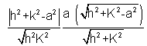
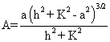
Note that h² + k² > a² (h, k) lies outside the circle. 1 center
2 circle
3 Radius
4 Diameter
5 Semicircle
6 Chord
7 Tangent
8 Normal
9 Chord of contact
10. External touch
11. Internal touch
12. point of contact
13. Direct tangent
14. Transverse Tangent
15. Concentric

